Market Segmentation

Satyam Pravinkumar Sharma

2nd May 2024

**Github - https://github.com/Satyam-2004/Market-segmentation-EV**

**1.0 Introduction**

India is witnessing a significant change in how people get around, largely because more and more folks are choosing electric vehicles (EVs). This shift is being by factors like rapid urbanization, a growing population, and higher incomes, all of which are making EVs a popular choice as greener option. Electric two-wheelers, in particular, are leading the charge due to their affordability and widespread appeal. They’re not just changing how people travel in India, they’re also offering a way to tackle pollution and reduce greenhouse gas emissions.

The Indian government has been instrumental in making this happen by putting in place policies that encourage local production and support a strong network of manufactures, dealers, and service providers. As of 2023, the electric two-wheeler market in India has hit its peak, showing that these efforts are paying off and that clean transportation is gaining traction.

This research dives deep into this transformation, with a focus on the electric vehicle industry, especially electric two-wheelers. By analyzing consumer behavior, psychographic data, and vehicle details, we offer insights into pricing that can benefit consumers, policymakers, and industry players alike. Understanding what consumers want and need is key to building a sustainable, environmentally friendly, and consumer-driven electric transportation system in India.

**Problem statement**

Our goal is to effectively place our Electric Vehicle Startup in the Indian market by using data-driven information from customer review (which include behavioral and psychographic data. We aim to use this information to divide the market into segments and suggests which segments to target for our electric vehicles.

**3.0 Fermi Estimation**

**3.1 Gathering and Evaluating Data**

* Gather sales data, electric vehicle customers reviews.
* Examine the depth of the data that has been gathered. This involves analyzing the accuracy, consistency, and scope of the information collected to ensure that it is reliable and covers all relevant aspects of the subject under study.

**3.2 Segmenting Through Behavioral Factors**

* Leverage behavioral data to discern trends and divisions among the customer demographic.
* Use data-driven methods to gauge both the scale and attributes of every segment.

**3.3** **Evaluation of Psychographic Information**

* Examine psychographic data within each behavioral segment to understand customer preferences and motivations.
* Assess the psychographic characteristics and preferences within each segment.

**3.4 Target Segment Selection**

* Choose target segments after a comprehensive analysis of behavioral, psychographic, and technical aspects.

**3.5 Tailoring the Marketing Mix**

* Create a personalized marketing mix designed specifically for the chosen target segments.
* Assess the efficacy of different marketing strategies within the chosen target segments, ensuring they align with customers preferences.

**3.6 Segment Recommendation: Identifying Ideal Target Groups**

* Integrate the outcomes of segment analysis with the findings from customizing the marketing mix to conclude segment recommendations.
* Recommend target segments with the greatest projected market potential, ensuring a concentrated and precise market entry approach.

**4.0 Data Collection**

In this project, information was collected from three different origins. This dataset presents a thorough overview of market trends and consumer preferences over the specified duration. The dataset, acquired from bikewale.com, consists of customers reviews specifically for electric two-wheelers, providing crucial insights into both behavioral and psychographic aspects. These qualitative inputs were extremely beneficial in gaining a deeper understanding of consumer behavior.

**5.0 Segment Extraction: Isolating Target Demographics**

**5.1 Profiling Segments**

The graph illustrates varied perceptions among segments. Segment 0 (15% of consumers) values visual appeal, reliability, performance, service experience, and comfort. Segment 1 (39%) is the largest but least satisfied group. Segment 2 (33%) appreciates visual appeal, reliability, service, comfort, and sees strong value for money. Lastly, Segment 3 (13%) values visual appeal, reliability, performance, service, features, and maintenance costs, with unique views on features and expenses.

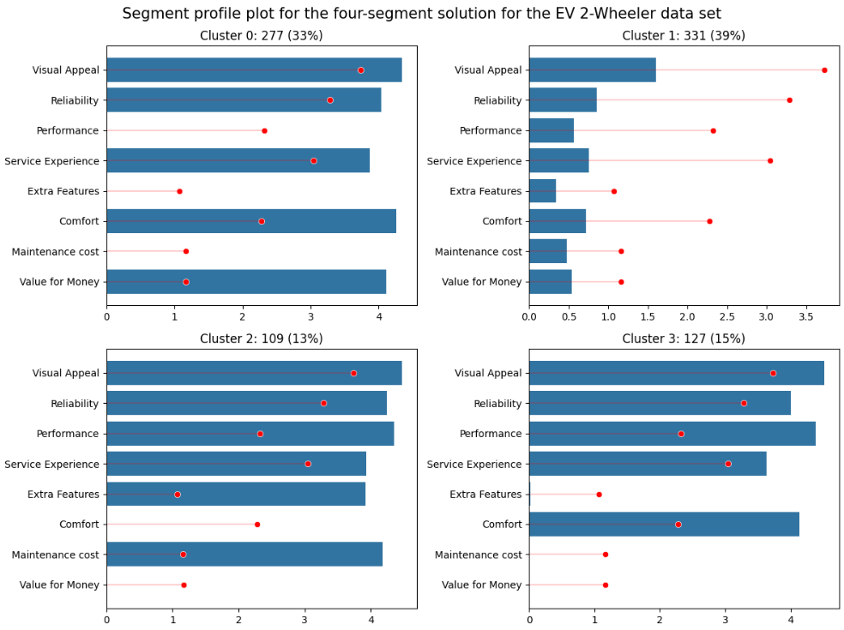

**5.2 Segment Description: Detailing Segment Characteristics**

This section offers a thorough overview based on insights drawn from various mosaic plots and graphical representations. As depicted in the mosaic plot shows that the primary use of electric vehicles across all segments is for daily commuting, with limited usage for tours, occasional commuting, and leisure rides. Transitioning, the plot illustrates the duration of electric vehicle ownership among segments. Segments 1 notably stands out, with ownership exceeding one year, whereas Segments 0 lacks prior ownership experience. Members of Segments 2 possess vehicles for a moderate duration ranging from less than three months to over a year, while Segment 3 consumers have owned electric vehicles for a few days to less than three months.

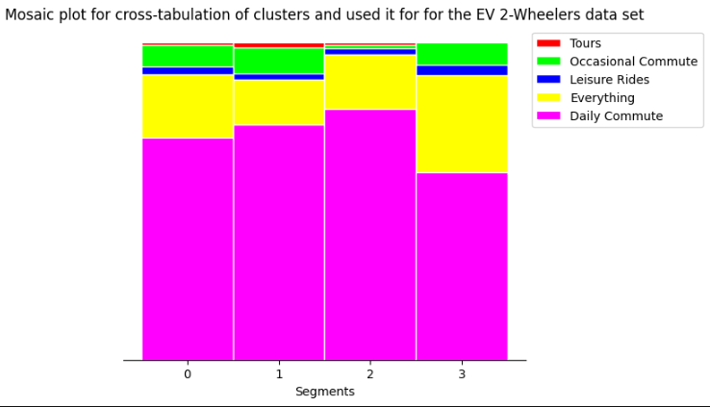

Plot showcasing electric vehicle usage patterns across segments

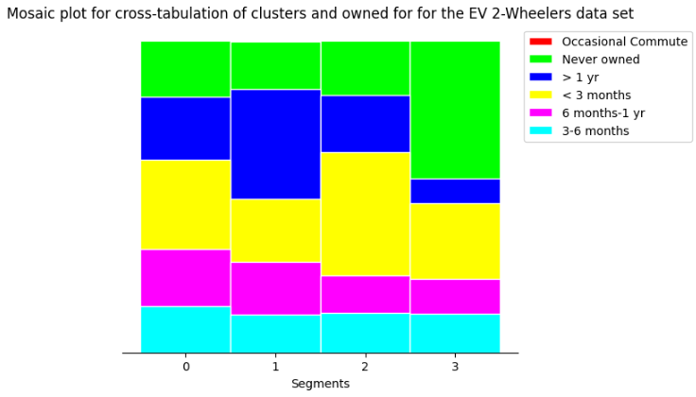

Explores the distances traveled by consumers, revealing that electric vehicles are primarily utilized for commuting across all segments, with the majority of users covering distances below 5000 kilometers. A small proportion falls within the 5000 to 10000 kilometers range, which corresponds to their commuting requirements.

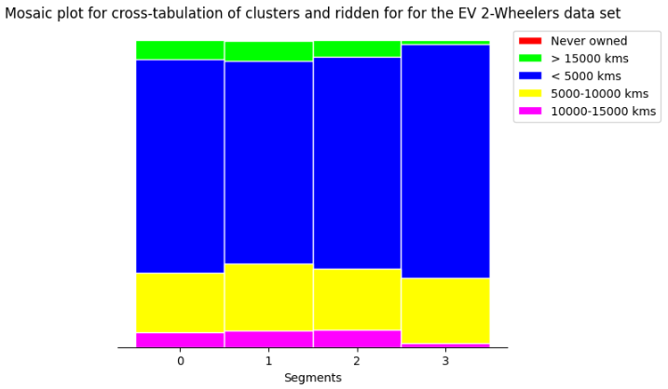

Consumer sentiments are examined, with all segments, expect Segment 1, displaying positive sentiments. Segment 1 consumers stand out with negative sentiments, signaling dissatisfaction across various aspects. A parallel box and whisker plot highlights notable differences in average ratings among segments. Specifically, Segment 1 consumers express discontent across all perceptions, resulting in lower overall ratings. These graphical representations providing detailed insights into consumers behaviors, sentiments, and preferences, informing strategic decisions for a more customized approach in the electric vehicle market.

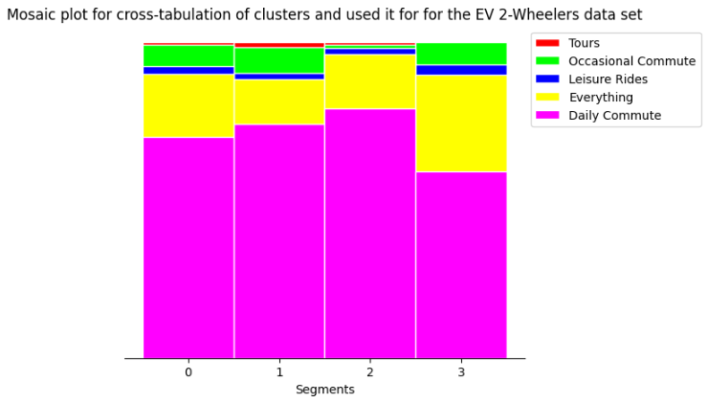

Regrading riding range, Segments 0 stands out with a preference for electric vehicles offering extended range. In contrast, Segments 1 and 2 focus on moderate ranges suitable for daily commuting, while segment 3 caters to consumers desiring slightly longer distances, reflecting nuanced commuting needs.

When considering top speed, Segment 0 and 3 prefer vehicles with higher speeds, while Segments 1 and 2 prioritize lower speeds suitable for city commuting.

Weight also plays a significant role, with Segments 0 and 1 favoring slightly heavier vehicles. Segments 2 and 3 lean towards lighter options, accommodating diverse users preferences for vehicles weight.

Lastly, battery charging time demonstrates a notable difference, with Segment 0 and 3 opting for slightly longer charging durations, emphasizing the convenience of overnight charging. In contrast, Segments 1 and 2 prioritize faster charging, catering to users seeking quicker turnaround times for their electric vehicles.

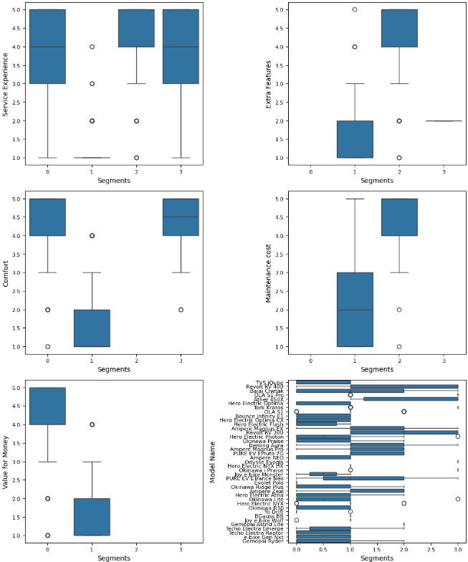

**6.0 Prospective Early Market Customer Pool**

After thorough analysis and evaluation, Segment 1 emerges as the most optimal market segment for our electric two-wheeler vehicles. Comprising 39% of consumers, this segment presents substantial opportunities and a sizable customer base, making it strategically advantageous for market penetration. Its significant market potential, combined with a well-balanced mix of technical specifications and price range, positions it as the most promising market segment for our electric vehicles.

**7.0 Conclusion**

In conclusion, our extensive analysis of Indian’s electric vehicle market had led us to pinpoint Segment 1 as the optimal target. With a substantial 39% consumers base, this segment presents a significant market opportunity. By customizing our electric two-wheeler specification align with the demands of a large customers base. This strategic decision is underpinned by a comprehensive understanding of market segmentation, consumer behavior, and technical specification.

These insights provide a clear roadmap for our market entry, emphasizing precision and relevance in both product development and marketing strategies. Looking ahead, this approach furnishes us with a robust foundation, ensuring that our offering resonate effectively within India’s evolving electric vehicle landscape.